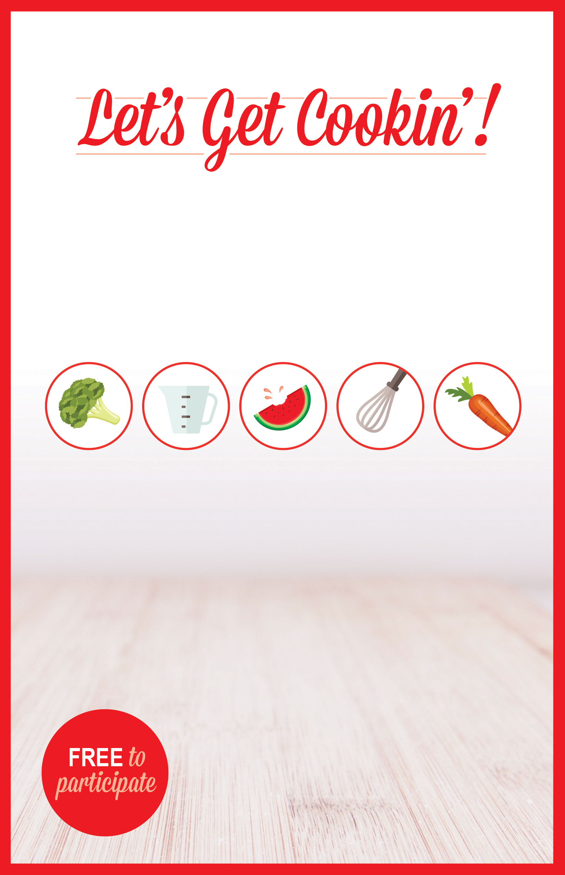

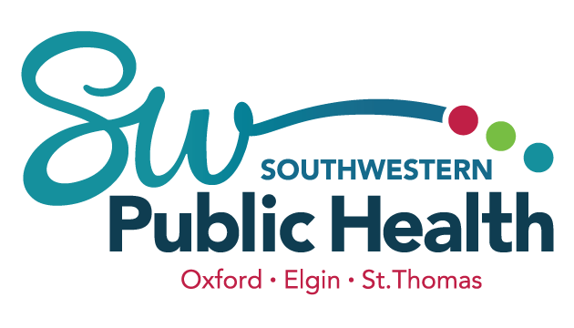

Learn to cook snacks and simple meals.

Enjoy sampling new recipes.

Learn about handling food safely.

Have fun with friends.

PROGRAM WILL BE HELD:

Copy goes here

Copy goes here

Copy goes here

Copy goes here

PICK UP THE PERMISSION FORM:

Copy goes here

Copy goes here

Copy goes here

Copy goes here